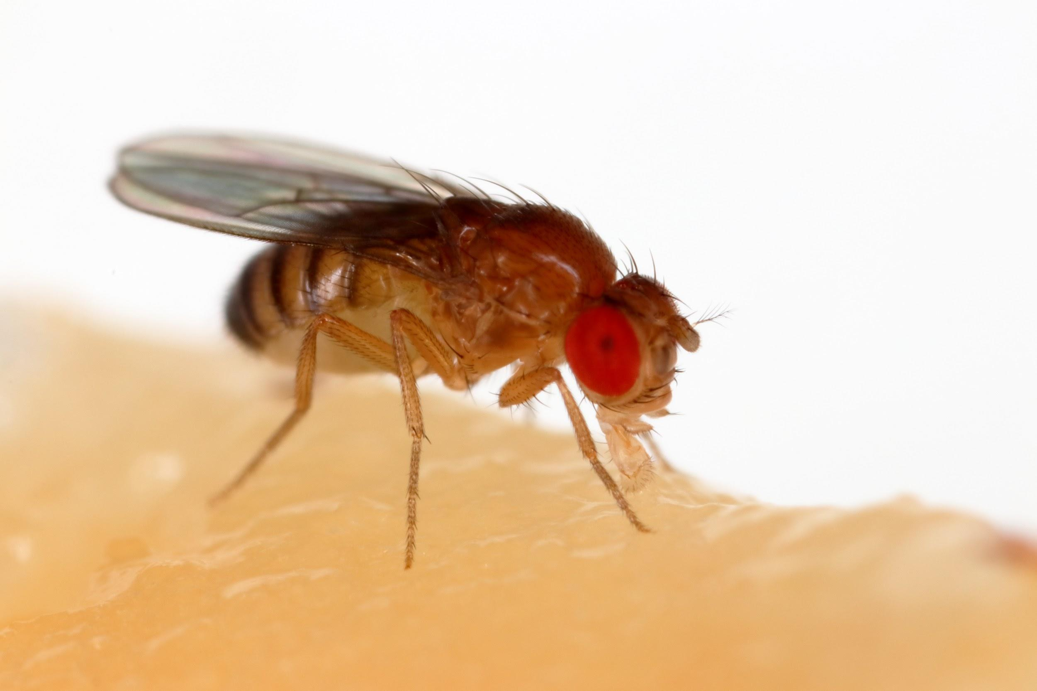 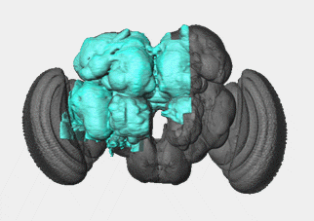

**Reference Sheet: Exploring the Hemibrain**

**Basic Concepts/Background**

* Fruit Fly neurons are different from vertebrate neurons. The soma of fruit fly neurons migrate to the outside of the brain and do not receive any inputs from other cells at the soma location.
* Orientation of EM data: The orientation of the data is based on the fruit fly's perspective. The data is viewed head on as if the fly is looking at you. Your left is the right side of their brain and your right is the left.
* Neuron A -> Connects To-> Neuron B (super simple relationship)
  + Reference property graph for breakdown
* Neurons:
  + Receive information at their dendrites
  + Send out information from terminal buttons

**Terminology**

* Connectomics - the production and study of comprehensive maps of connections within an organism's nervous system.
* ROI/primary ROI - Region of Interest. Areas within the brain that are grouped together due to the shared function/which types of call pass through. Primary ROI will hold smaller sub ROIs
* T-Bar/Pre - Location on neuron that send out neurotransmitters into synaptic cleft
* PSD/Post - Location on neuron where receptors absorb neurotransmitters. Postsynaptic Density
* Morphology - General physical structure of a neurons body, related to function of neuron
* Percent Completeness - The number of synaptic sites that belong to a completed body divided by the number of all synaptic sites in a specified ROI.
* Post: Pre Ratio - The ratio of Postsynaptic sites to presynaptic site. Most neurons will have more postsynaptic sites than presynaptic.
* Neuprint: Database that contains all the connectomic data for the hemibrain; pronounced (new-print)
* Cypher: A SQL based language used to query Neuprint
* Neuprint-Python: API access to database
* Antennal lobe - Region of Interest that receives olfactory inputs from olfactory sensory neurons
* MBONs - Mushroom Body Output Neurons. Neurons that integrate sensory information in the learning/ memory center.
* Mushroom Body: ROI associated with olfactory learning and memory formation. One of the most well study areas of the brain
* *Drosophila Melanogaster* - Scientific name for a fruit fly!

**Useful Graphics**

1. Property Graph for Neuprint

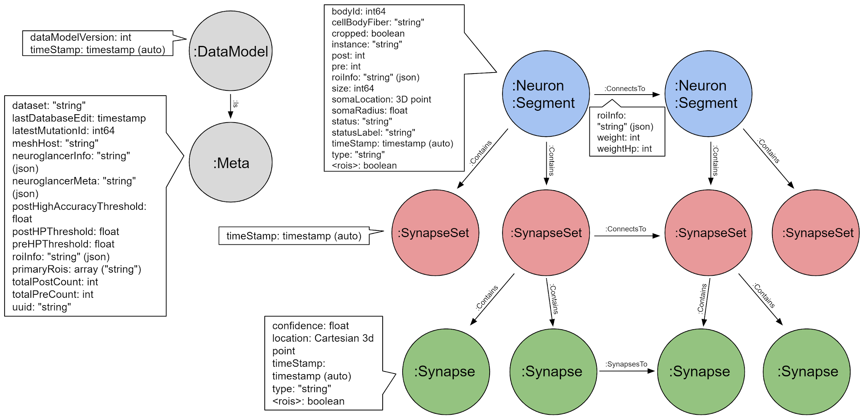

1. Primary ROI breakdown with corresponding sub ROIs

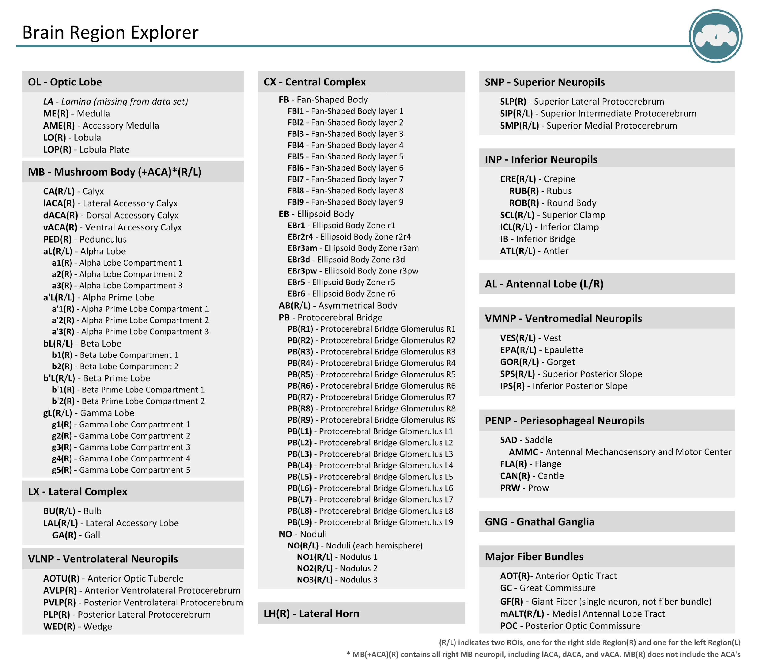

**Useful Links**

[Web Access to Neuprint Database](https://neuprint.janelia.org/) **-** You must create account with a gmail address to query database and receive authorization token for API access

[Github for all Neuprint related capabilities](https://github.com/connectome-neuprint) - for API access please refer to the Neuprint-Python Repository

[Neuprint-Python Documentation](https://connectome-neuprint.github.io/neuprint-python/docs/) - Refer to for all calls

[Published paper of the connectome](https://elifesciences.org/articles/57443)

[Introduction to the Hemibrain](https://www.janelia.org/sites/default/files/Project%20Teams/Fly%20EM/1.1%20191004_HemibrainDataset.pdf) - Simple breakdown of the dataset with plenty of detail

[Janelia FlyEm web page for Hemibrain work](https://www.janelia.org/project-team/flyem/hemibrain)

[Video of brain dissection](https://youtu.be/aGcnJeqEVEk?t=67) - If you’re interested a video on how the dissection of the brain is done

**Questions?**

You can contact Chelsea (works on data set everyday) via slack or email ([cxa6ky@virginia.edu](mailto:cxa6ky@virginia.edu))